Topic: Files and Folders
When I am done this lesson, I will know:
- What a file and a folder are
- Icons for common file types
- How to save a file in Windows
- How to create folders and organize files
- Some tips for saving and organizing files
Pre and Post Self-Assessment
 | Pre | Pre | Post | Post
 | Yes, I know this | No, I want to learn this | Yes, I know this | I still need more practice to learn this
I know what a file and a folder are
I know how to create folders and organize files

New Words and Terms

file
folder
PDF

What are Files and Folders?
A file is the common storage unit in a computer, and all programs and data are "written" into a file and "read" from a file. Different types of files have different icons to help you know what type of file it is.
Here are some common icons you may see for files:
 | PDF Icon  PDF is an acronym for Portable Document Format. PDF is a file format that provides an electronic image of text or text and graphics that looks like a printed document and can be viewed, printed, and electronically transmitted using a PDF viewer like Adobe Acrobat.
 | Microsoft Word file Icon  Word is word processing software.
 | Microsoft Excel Icon  Excel is a spreadsheet program.
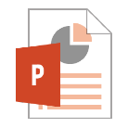 | Microsoft PowerPoint Icon  PowerPoint is presentation software.
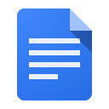 | Google Docs Icon  Google Docs is word processing software you can access on Google Drive.
 | Apple Pages Icon  Pages is word processing software for MAC.

A folder holds one or more files, and a folder can be empty until it is filled. A folder can also contain other folders, and there can be many levels of folders within folders. Folders are used to create a filing system online. Folders help you organize your files so you can find them easily. All operating systems and cloud storage services allow you to create and organize folders.
If you are using the Windows operating system, there are already several different types of folders already created:
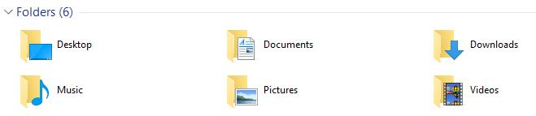
How to Save a File in Windows
There are generally five steps to saving a file:
- Click “FILE” from inside the application or software you are working in. This is usually in the upper left-hand corner of your screen.
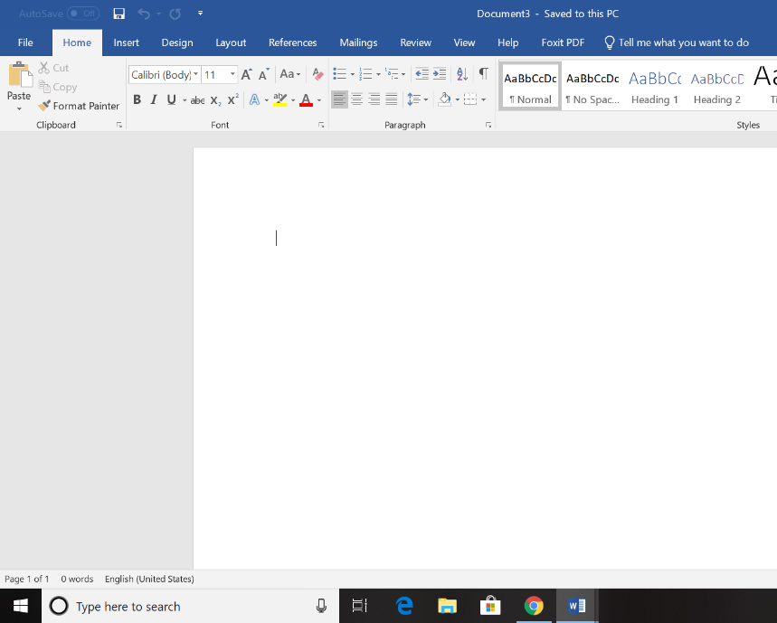

- Select the “Save As” menu item.

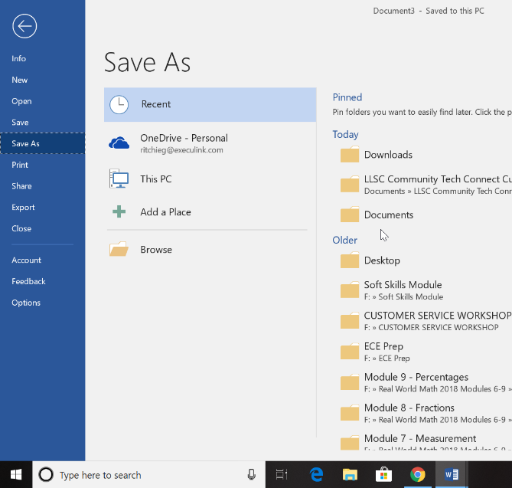

- Choose where you want the file to be saved.
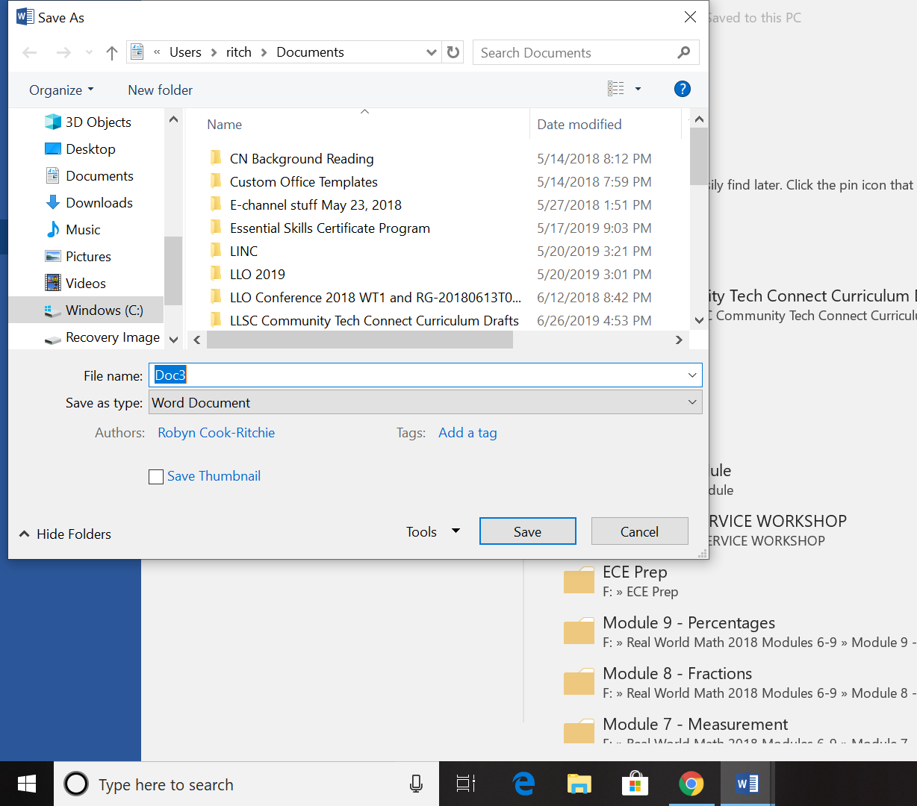

- Change the file name.
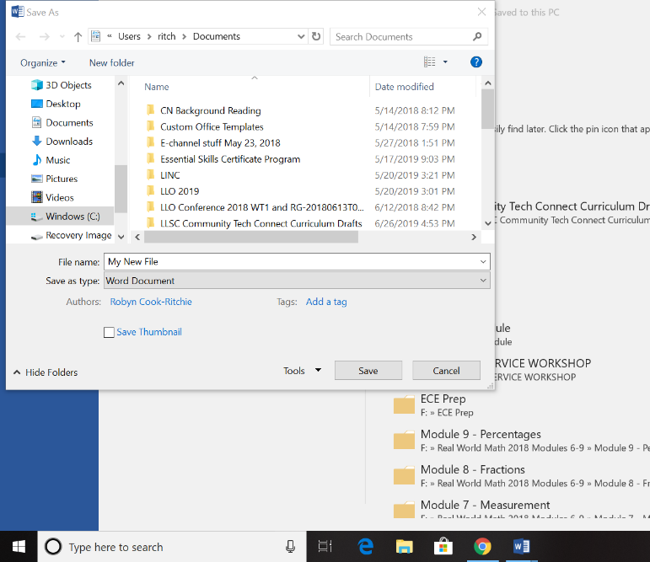

- Click “SAVE.”

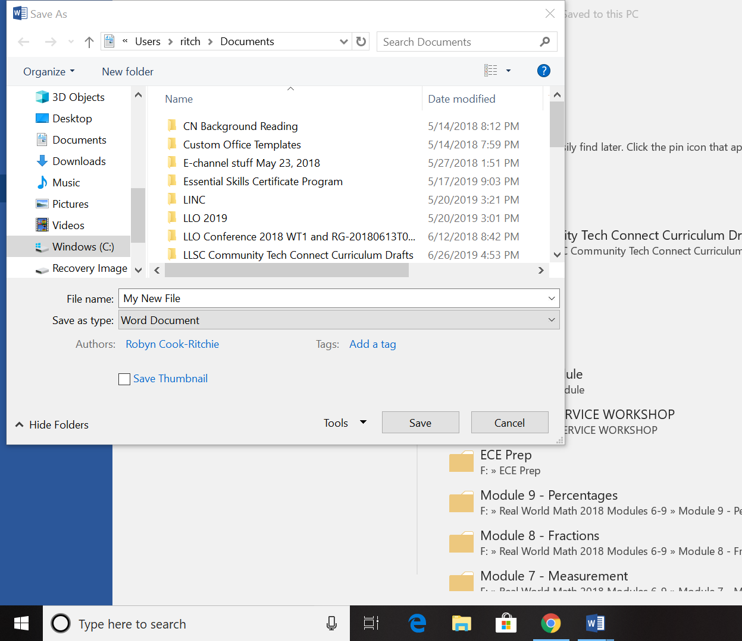

Check Your Knowledge
List the five steps to saving a file:
1.
2.
3.
4.
5.

Creating Folders and Organizing Your Files
Complete the tutorial to learn how to create folders and organize your files in Windows.  Source: GCFGlobal | https://edu.gcfglobal.org/en/windowsbasics/working-with-files/1/

Try this/Practice
If you have access to a computer, try creating and saving a file. Create a new folder and move the file you created to the folder you created.
Tips for Saving and Organizing Your Files
- Skip the Desktop. Never ever store files on your Desktop. It looks messy and cluttered.
- File or delete downloads. Don’t let files sit in your Downloads folder. Either file them where they belong or delete them.
- File things immediately. If you wait to file things, your system may get out of control. As soon as you create or receive a file, put it in a folder.
- Sort everything once a week. Tidy things up, delete any unnecessary files, and generally stop things getting messy at least once a week.
- Use descriptive names. When you’re naming your files, give them descriptive names. “Wednesday” is not a great name. “Wednesday – Journal Entries – January” is much better.
- Search is powerful. The Search feature within most operating systems is really powerful. If you can’t find a file by looking, try searching for it. If you’ve named your files and folders correctly, it will be easy to find.
- Don’t use too many folders. Having too many nested folders gets annoying. Each folder should have a minimum of about 10 files in it. If you only have two or three files in each folder, you need to reconsider your filing system.
- Stick with it. Don’t just give up after a few days. Commit to using your file structure for a couple of weeks before scrapping it.
Source: Adapted from: https://business.tutsplus.com/tutorials/how-to-organize-computer-files--cms-32191 (last accessed July 5, 2019).

Ontario Adult Literacy Curriculum Framework Connection
Competency | Task Group(s)
Find and Use Information | - Read Continuous Text (L3)  - Interpret Documents (L2 - complex format, subheadings/subparts)  - Extract Information from Films, Broadcasts and Presentations (not levelled)
Communicate Ideas and Information | - Complete and Create Documents
Use Digital Technology | - Organize Digital Files into Folders  - Watch Podcasts




Literacy Link South Central
(March 2020)
www.llsc.on.ca literacylink@llsc.on.ca

